MULTIPLE REGRESSION

INTRODUCTION: The simple linear regression model is used to determine the effect of a single independent variable on the dependent variable.
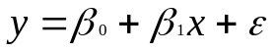

However, we are often interested in testing whether a dependent variable (y) is related to more than one independent variable (x₂ , x₃, x₄, …) and there by the emphasis is on the estimation and inferences. The above said process is known as multiple regression and indeed, this is commonly done. However, it is possible that the independent variables could observe each other’s effects. For example, a choice of a restaurant can depend on factors like cost, convenience and ambience. The cost effect might over rid the convenience effect, leading to a regression for cost which would not appear very interesting.

One possible solution is to perform a regression with one independent variable, and then test whether a second independent variable is significant with respect to the residuals from this regression. Then the second variable is included. Continue in a similar manner to include other independent variables.

A multiple regression allows the simultaneous testing and modeling of multiple independent variables.

The model for a multiple regression (called the POPULATION REGRESSION MODEL) takes the form:

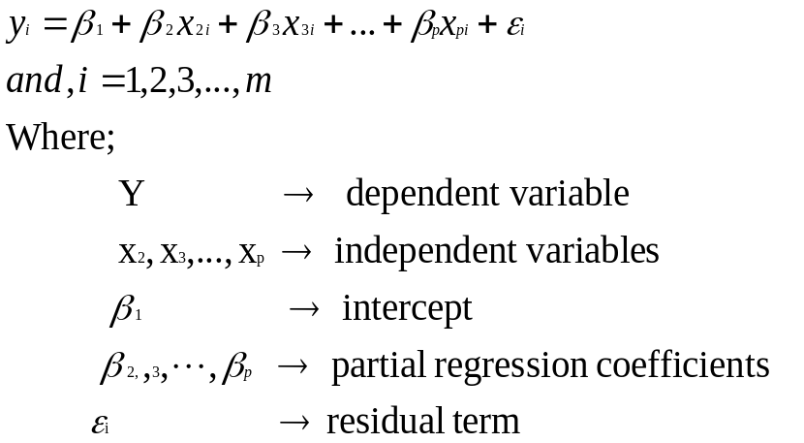
Suppose in the above model, if the population size is ‘m’ (>n) the values of Y₁, Y₂,…,Y_{m} could be explained as follows. By observing the equations we could see that there are common parameters which are likely to be bound that, these parameters are β₁, β_{2,}…,β_{p}. Then, the ‘p’ dimensional representative plane looks like

For any observation the representative plane is used to deduce the observation.
e.g. For i^{th} observation assume that i^{th} observation = 70 is observed, the representative plane provides value 68, then (70 – 68) provides the error term _{i} = 2, suppose j^{th} observation = 80, the representative plan provides value of 76 then (80 – 76) is the error term _{j} = 4.

Here, there are ‘m’ observations in the population and ‘p’ variables (Y, X₂, X₃,…,X_{p}), _{i} is the residue attached to each observation. (Residue is the difference between the actual Y value and predicted y value(y^ ) from the model).

Thus the system of equations are:

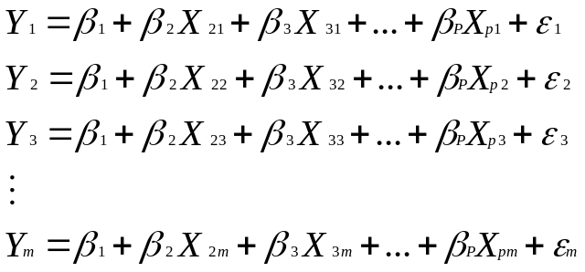
The above set of equations can be reduced to a matrix form as shown below:
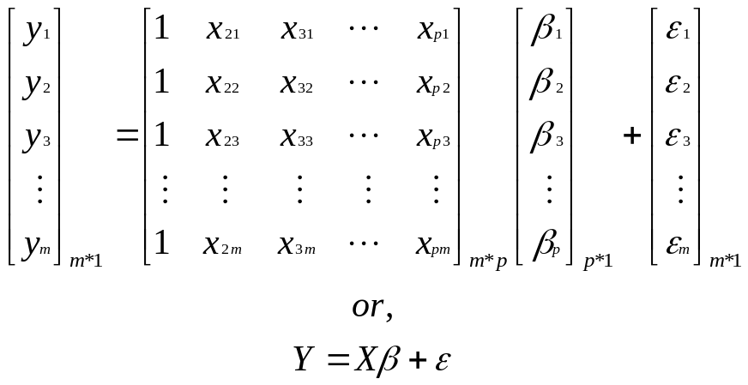
In the X matrix, x_{ji} corresponds to j^{th} variable and i^{th} observation.

But in reality we don’t know the population size, then collect the sample observation and estimate the parameters of the population from the sample observation, and then estimated parameters constitutes the sample representative plan.
i.e. Our aim is to estimate the values of β₁, β₂,…,β_{p} by obtaining data from a sample of the population. Thus, the sample regression equation is as under.
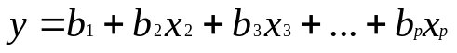
Above concept is portrayed through a diagram as shown below for one independent variable.
b₁
β₁
Population Regression Model
Sample Regression Model
Y
0
X
ε_{i}
*
*
*
*
*
*
*
*
*
*
*
*
*
*
*
*
*
*
*
*
*
*
*
*
*
*
*
*
*
*
*
*
*
*
*
*
*
*
*
*
*
*
*
*
*
*
*
*
*
*
*
*
Y^ i
Yi
yi
y^ i
e_{i}
Sample
Population

y^ _{i} is the expected value of y_{i} at x_{i} [E (y/x_{i})] in the population regression model. Y^ _{i} is the expected value of yi at x_{i} in the sample regression model.

Our entire work is to calculate the values of b₁, b₂, b_{3,} . . . , b_{p} from the sample drawn out of the population and then estimate the partial regression co-efficients (β₁,β₂,β₃, …,β_{p}) of the population. Here; b₁ is the estimator of β₁, b₂ is the estimator of β₂ soon on b_{p} for β_{p}.

If there are 2 variables (1 dependent and 1 independent ) we will be fitting a line, for 3 variables ( 1 dependent and 2 independent) we will be fitting a plane and 4 variables ( 1 dependent and 3 independent) a space.

Multiple regression techniques have a wide application right from prediction of a Tornado to evaluation of a restaurant to have the next meal.

Assumptions: The multiple regression model operates under certain assumptions. These are :-

- The error term is independent of each of the independent variables. i.e. the covariance cov (ε, X_{i}) = 0.
Since, the regression equation is y = f(x) + ε, and our aim is to
minimize the error i.e. ε² = [Y – f(x)]². This becomes difficult if the
independent term influences the error term.
- The errors for all possible sets of given values of x₂, x₃, x₄, …, x_{p} are normally distributed.
- The expected values of the errors is zero for all possible sets of given values of x₂, x₃, x₄,…
i.e. E (ε_{i}) = 0
- The variance of the errors is finite and is the same for all sets of given values of x₂,x₃,…i.e. variance (ε_{i}) = σ² is a constant.
- Any two errors are independent i.e. one error is not the cause if another.
- The model should include only those variables which do not have relationships among themselves. i.e., no multi collinearity. If there is a muticollinearity then one independent variable could be estimated by another independent variable as it, like
X₂ = K₁ + K₂X₃.

TYPES OF REGRESSION FOR TYPES OF DATA: Different types of regressions exist for different types of data.

Dependent Variable | Independent Variable | Name of the regression
Metric | Metric | Ordinary regression
Non-metric | Non metric | Logistic regression
Metric | (Metric and Non metric)Or non metric | Dummy regression

Analysis of Multiple Regression Technique: The foremost task is to find the sample representative regression model. The model is constituted by the values of b. The most commonly used method of arriving at the estimators is using the method of ordinary least squares. The method of ordinary least square is explained as follows:
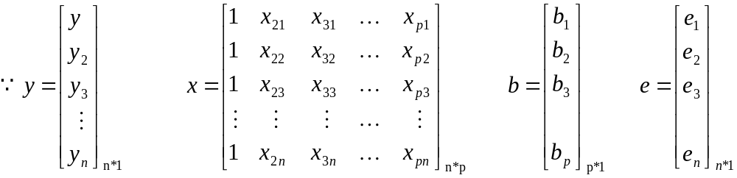
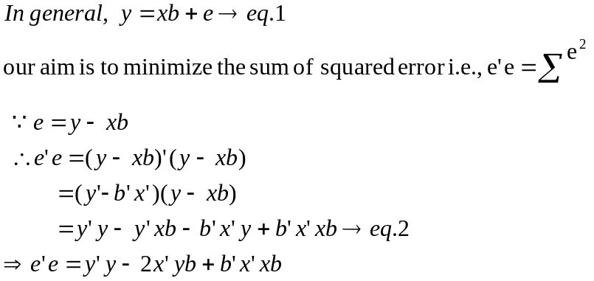

Here all the terms become scalar quantities. Hence, sum of squared error (e’e) should be partially differentiated by b and equate it to zero to estimate the value of ‘b’.
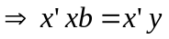

The above equation forms the basis of formulating the best ‘p’ dimensional plane. Let us see how the above equation enables to find the line with two variables (y, x2). For ‘n’ observations, therefore,

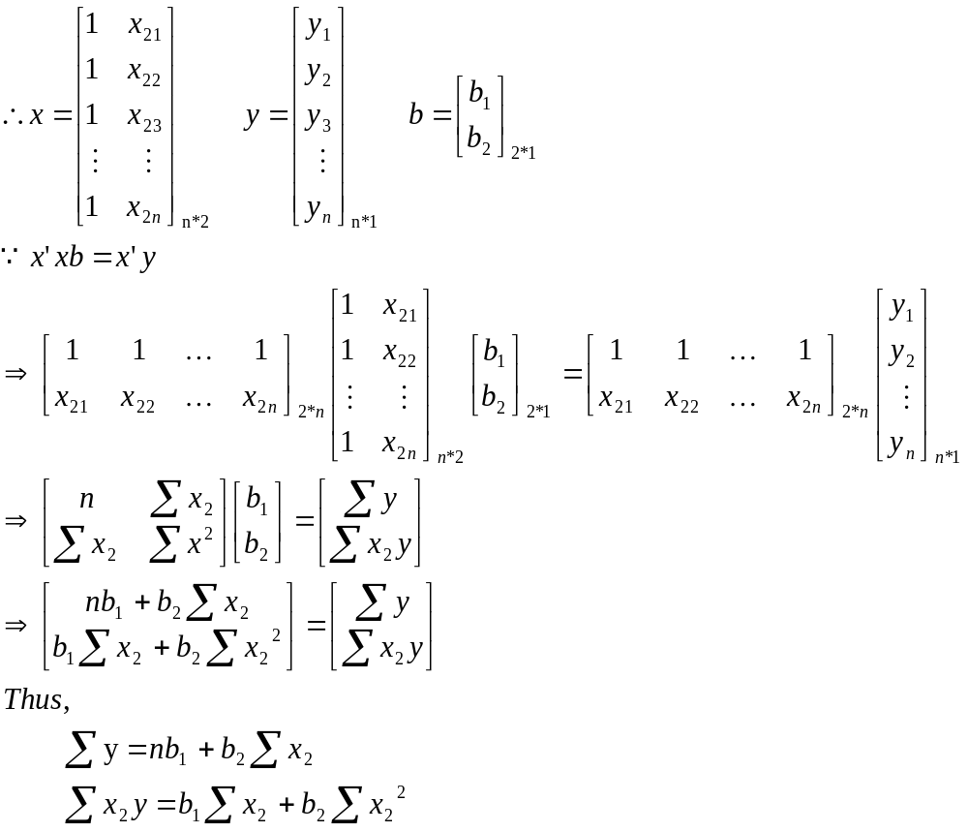

Solving the above, we can obtain the values of b₁ and b₂. They are the estimators of β₁ and β₂ respectively.

Following is the formulation of the ordinary least square method for three variables. (1 dependent y, two independent variables-x₂, x₃). For ‘n’ observations
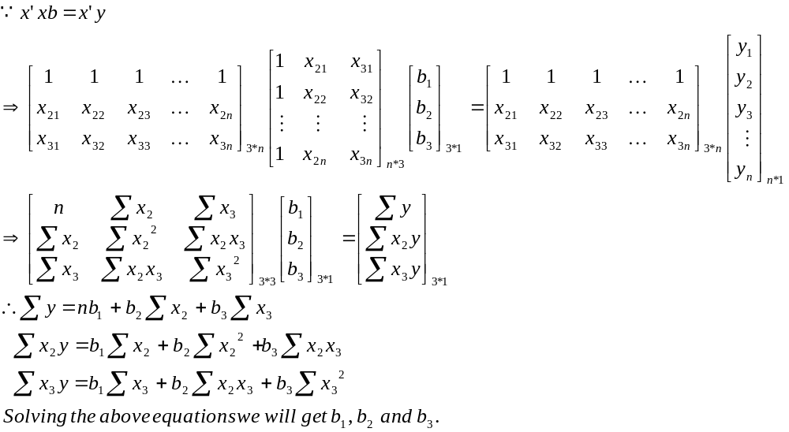
This could be similarly extended to p variables consisting of 1 dependent variable and (p-1) independent variables. When more number of variables are included in the model, it will be cumbersome to solve the equations. So it is better to adopt matrix methods, for that many softwares are available like matlab, scilab. In this book, matlab 6.1 is used to arrive at the estimators.

Steps in obtaining multiple regression model:

- Get the different observation of y, x₂, x₃, …, x_{p}
- Estimate the regression co-efficient, (b₁, b₂, b₃,…, b_{p})
- Go for statistical inferences like Anova, t – test, R².
- Arrive at optimum number of variables (Independent) to be included in the model. (This is done by forward, backward, stepwise regressions which are discussed later).

Let us take an example to illustrate multiple regression and corresponding statistical inferences.

Step 1: The post – tax profit margin (y₁) is a function of dominant specialization (x₂), vertical integration (x₃), import dependence (x₄), R & D Intensity (x₅), export competitiveness (x₆) and capital intensity (x₇). There are 16 observations for these variables from 1974 - 75 to 1989 – 90.

Year | Dominant specialization | Vertical integration | Import dependence | R&D intensity | Export competitiveness | Capital intensity | Post-tax profit margin
Year | (X2) | (X3) | (X4) | (X5) | (X6) | (X7) | (Y1)
1974-75 | 70.58 | 22.03 | 18.29 | 1.48 | 3.61 | 4.3 | 1.27
1975-76 | 75.39 | 21.93 | 18.56 | 1.7 | 4.38 | 4.71 | 1.39
1976-77 | 74.43 | 23.6 | 16.77 | 1.81 | 5.88 | 4.63 | 3.2
1977-78 | 73.51 | 21.27 | 15.16 | 1.77 | 7.8 | 4.48 | 3.12
1978-79 | 74.78 | 20.04 | 15.43 | 1.96 | 6.92 | 4.1 | 3.19
1979-80 | 71.73 | 19.34 | 16.92 | 2.62 | 6.11 | 4 | 3.28
1980-81 | 72.34 | 18.27 | 17.92 | 3.39 | 5.31 | 3.75 | 4.41
1981-82 | 73.14 | 18.91 | 16.06 | 2.97 | 5.18 | 3.64 | 5.06
1982-83 | 76.31 | 17.33 | 15.93 | 2.12 | 5.63 | 3.85 | 4.17
1983-84 | 75.4 | 17.72 | 15.52 | 1.88 | 4.11 | 3.9 | 3.27
1984-85 | 75.37 | 18.76 | 14.23 | 2.6 | 4.49 | 3.91 | 3.41
1985-86 | 73.03 | 18.32 | 16.03 | 2.16 | 3.37 | 3.9 | 2.52
1986-87 | 74.66 | 17.56 | 17.35 | 1.6 | 2.64 | 3.96 | 1.08
1987-88 | 77.51 | 16.79 | 16.44 | 1.84 | 2.91 | 4 | 1.16
1988-89 | 77.32 | 17.76 | 16.04 | 1.6 | 3.4 | 3.62 | 2.24
1989-90 | 77.3 | 18.14 | 15.34 | 1.94 | 4.38 | 3.73 | 3.06

Thus, the model is

Step 2: Solving; x’xb = x’y, we will get …

b1 = - 3.0472, b2 = 0.0930 b3 = 0.2502, b4 = -0.1015, b5 = 1.1341, b6 = 0.3785, b7 = 2.0715.

Thus,

Now we can predict the value of y1 for next coming years if we know the corresponding values of x₂, x₃, …, x₇.

STEP 3: Here effort has been made to explain the statistical inference through one independent variable and one dependent variable. Statistical Inferences for more than two independent variables is difficult to explain pictorially. Consider the below diagram, it is better to remember that the variances are measured from the average.
0
Y
X
y–
Mean
y^ - predicted
y Actual
Total
variation
(y- y^ )
Unexplained variation
*
*
(y^ - y– )
Explained variation
It has a dependent variable (y) and independent variable (x) and let “y” be the actual observation for corresponding “x”. A model for ‘n’
observations is found out to be 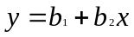.
Thus, for i^{th} observation we will have y_{i} actual, and y^ _{i} – predicted value
obtained from the model by substituting x_{i.} Now, from the figure we can observe that there is variation between y actual and y^ predicted; and y^ predicted and y– mean (means of all actual y values). The variation (y- y^ ) is called unexplained variation. The variation (y^ - y– ) is called as explained variation. The explained variation is explained by the established regression line. For the remaining variation (y- y^ ) it is difficult to attach any reasons. so it is called unexplained variation.
Our aim was to decrease this residue and fit a model which can predicated y values exactly as y actual values. i.e. reducing (y- y^ ) to zero. The remaining or explained variation due to regression is not of concern.
Test of significance of the model (ANOVA): ANOVA or Analysis of Variance is used to test the significance of the model. If it is were proved that the population regression coefficients i.e.,β₂,β₃,…,β_{p} are each not equal to zero then it can be concluded that the model is significant.

The ANOVA table looks like below:
Sources of variation | Sum of Squares | df | Mean Square | F-Value
Regression | 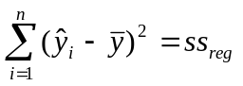 | p-1 | 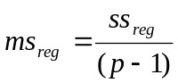 | 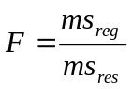
Residual | 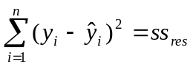 | n-p | 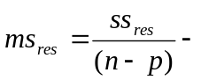
To test we formulate a Null Hypothesis stating that the partial regression coefficients are all equal to zero. i.e.,H₀: β₂ = β_{3 = . . . =}β_{p}=0. Alternative Hypothesis states that there is significance in the model due to regression i.e., H₁: β₂≠β₃≠ . . . ≠β_{p}≠0.i.e., there may be atleast one partial regression coefficient which is not equal to zero. This test helps mainly the variables (independent) has the relationship with the dependent variables. Note that the Null hypothesis is related to population.
Thus, the value of F to be calculated is:

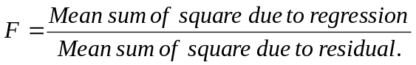

As the variation or the mean sum of square due to regression increased and/or the mean sum of square due to residual decreases the significance or F increases. Simply to put the total variation in the model is almost due to regression, which signifies what there is significance of the partial regression coefficients (β₂, β₃, …,β_{p}). Formula for F is

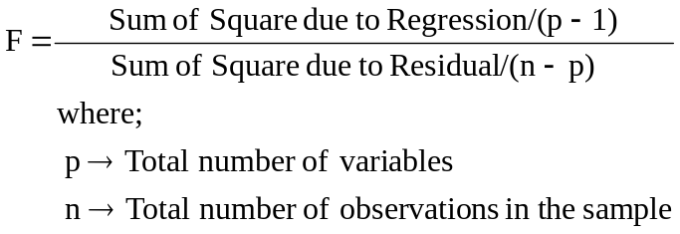

This value of F calculated is compared with the F Table value at (p-1) degrees of freedom (Numerator) and (n-p) degrees of freedom (denominator) at a significance level. If 99% is the confidence interval then significance is (100-99)% i.e., α=0.01.

Interpretation of F value: if the calculated value of F is more (shaded region) than the table value at a certain α then we reject Null Hypothesis, if it is less than F Table value we accept null hypothesis.

Y
0
α=0.05
α=0.10
α=0.01
X

Accepting null hypothesis means the obtained regression model is insignificant at that significance level. Accepting alternative hypothesis means the model is significant. In our example let us see the significance of the model using ANOVA.
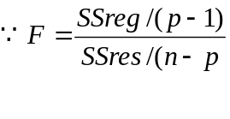
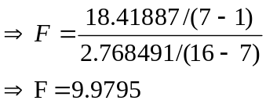
The F Table value at (p-1) and (n-p) i.e., 6 and 9 df at 5% (α=0.05) significance level is 3.37.
F Calculated Value > F Table Value/
Reject Null Hypothesis.
i.e., accepting alternative hypothesis stating that the model obtained is significant. In other words the variation in Y is Significantly explained by the partial regression coefficients (β₂, β₃, …,β₇).

But, the limitation of ANOVA test is that here it is able to check whether the model is significant or not. The significance of each of the coefficients (β₂, β₃, …,β_{p}) is not checked. The model might have been significant due to β₁ or β₂ or β₃or … or the combinations. Even there is possibility that one partial regression coefficient is significant then the test shows that the model is significant. To check whether there is any significant contribution by those coefficients individually to the model we have to use the t-test. Let us now discuss about the t-test.

t-test: Thus in the last section it was discussed how to determine whether a model is significant or not. But that was not able to determine the significance of each of the population’s regression coefficients. The t-test is used to determine the significance of each of the coefficients. To test the significance of coefficients the population in the model

The sample model is
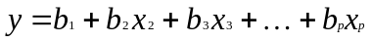

The Null Hypothesis in t-test states that there is no linear relationship between Y_{i} and X_{i}. Thus to test the significance of coefficient of b_{i} we formulate
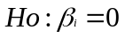
and the alternative hypothesis is
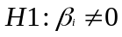

which means that there is a linear relationship.
Now, the t-test statistic,
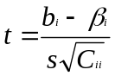
where, we assume that β_{i}=0 and thus this could be generalized as follows
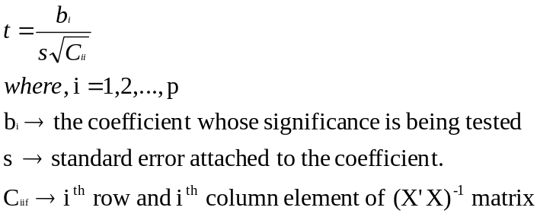
Standard error is calculated as
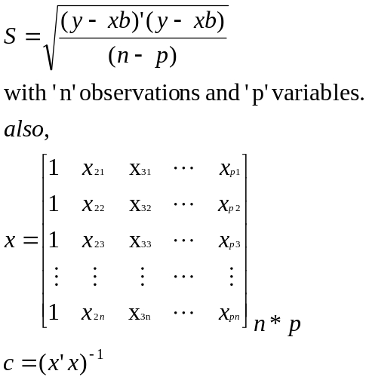
From above equations we can get the values of standard error (s) and (C_{ii}) to calculate the value of t. This value of t is checked with the table value of t at (n-p-1) df at a certain α level. This is a two tailed test, because alternative hypothesis is β_{i}≠0. If the calculated t value is more than the table value we reject the null hypothesis which means that there is a linear relationship between Y_{i} and X_{i}. Further it means that there is a considerable significance of “b_{i}” in the model at certain significance level.

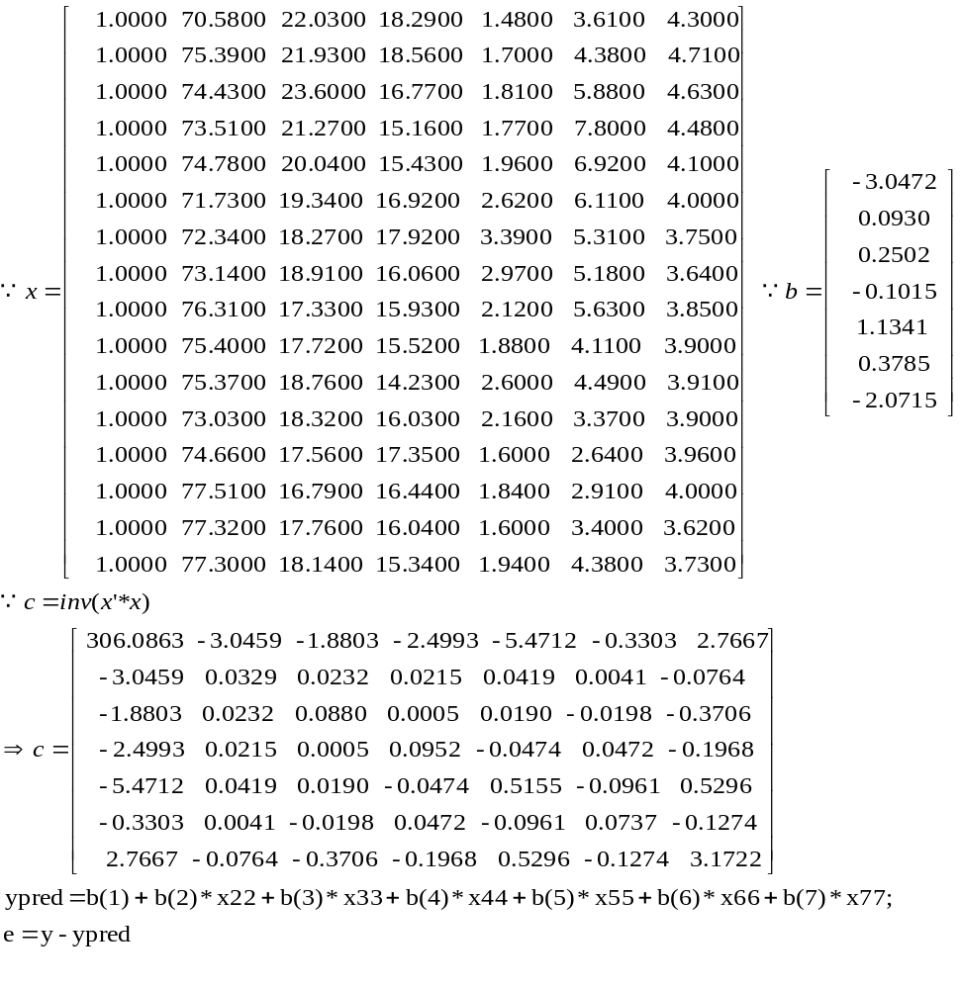
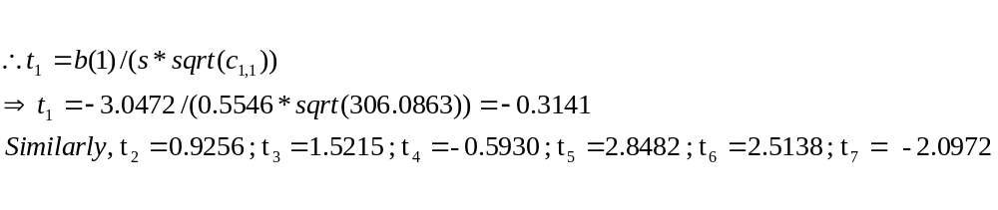
Co-efficient of determination (R²): This measure determines the strength of the model. The higher the variation due to regression in the total variation the higher the strength of the model or regression
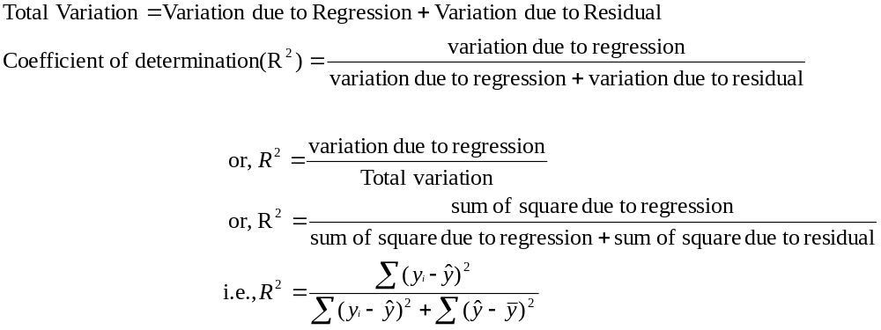
Year | Post-tax profit margin | Predicted from the model | Unexplained variation | Explained variation | Sum of Square due to Residual | Sum of Square due to Regression
Year | (Y1) | y1 predicted | y1 - y1 pred | y1 pred - y1 mean | ss_{res} | ss_{reg}
1974-75 | 1.27 | 1.309614 | -0.039614 | -1.554761 | 0.001569 | 2.417282
1975-76 | 1.39 | 1.396151 | -0.006151 | -1.468224 | 3.78E-05 | 2.155682
1976-77 | 3.2 | 2.764611 | 0.435389 | -0.099764 | 0.189564 | 0.009953
1977-78 | 3.12 | 3.251581 | -0.131581 | 0.387206 | 0.017314 | 0.149928
1978-79 | 3.19 | 3.704109 | -0.514109 | 0.839734 | 0.264308 | 0.705153
1979-80 | 3.28 | 3.743155 | -0.463155 | 0.87878 | 0.214513 | 0.772254
1980-81 | 4.41 | 4.519003 | -0.109003 | 1.654628 | 0.011882 | 2.737794
1981-82 | 5.06 | 4.644659 | 0.415341 | 1.780284 | 0.172508 | 3.169411
1982-83 | 4.17 | 3.328673 | 0.841327 | 0.464298 | 0.707831 | 0.215573
1983-84 | 3.27 | 2.432157 | 0.837843 | -0.432218 | 0.701981 | 0.186812
1984-85 | 3.41 | 3.760177 | -0.350177 | 0.895802 | 0.122624 | 0.802461
1985-86 | 2.52 | 2.34756 | 0.17244 | -0.516815 | 0.029736 | 0.267098
1986-87 | 1.08 | 1.139327 | -0.059327 | -1.725048 | 0.00352 | 2.975791
1987-88 | 1.16 | 1.595607 | -0.435607 | -1.268768 | 0.189753 | 1.609772
1988-89 | 2.24 | 2.561682 | -0.321682 | -0.302693 | 0.103479 | 0.091623
1989-90 | 3.06 | 3.254607 | -0.194607 | 0.390232 | 0.037872 | 0.152281
total | 45.83 | 45.752673 | 0.077327 | -0.077327 | 2.768491 | 18.41887
mean | 2.864375
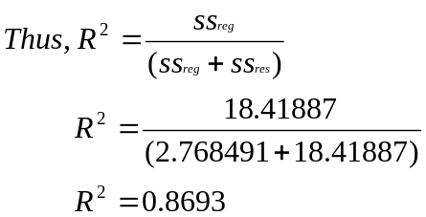
Thus, 86.93% of variation is explained by all the variables (x2, x3, …, x7) considered in our example in the prediction of y₁. We can say that our model is having strength 86.93%. When the value of R² is 1 then the fit is perfect.

Here the law of diminishing marginal utility can be used to explain the
relationship between the variables and R². When the first independent variable which is highly correlated with dependent variable is added then the strength or R² of the model is largely obtained. Then when second independent variable is added the contribution towards R² will be less than that of in the 1st variable’s case. Thus, when variables are added subsequently the increase in R² will become lesser and lesser.
Adjusted R² co-efficient: In determining R² the value of the co-efficient of determination is predominantly depending upon the numerator. The value of the numerator i.e. explained variation due to regression can be increased by adding additional independent variables into the model. So, to compare two models for same dependent variable like
y₁ = b₁₁ + b₂₁x₂ + b₃₁x₃ and ---------> 1
y₁ = b₁₂ + b₂₂x₂ + b₃₂x₃ + b₄₃x₄ + b₄₅x₅ ---------> 2
With the value of R² might lead to inappropriate conclusions.
The adjusted R² value is to be determined to compare 1 and 2. The adjusted R² value takes into account the number of independent variables in the model.
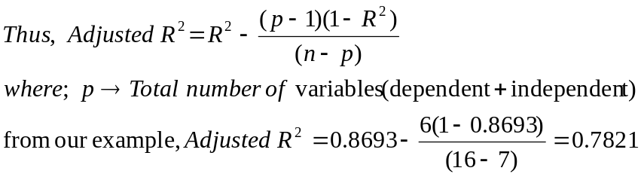
Thus, the adjusted R2 value is almost 8% less than the R² value. This is
because as the number of independent variables increases the adjusted R² will increase but less than that of R². Also, it should be noted that R² will take only positive values, but Adjusted R² can take negative values.
STEP 4: ARRIVING AT AN OPTIMUM MODEL: For a dependent variable y there could be ‘m’ number of independent variables x₂,x₃,x₄,…,x_{m} acting upon. For example, the price(y) of ice cream of a brand willingly paid by a customer can be dependent of availability of substitute products, seasonal variations, income levels, inflation, cultural tastes, prices of competitors, and cost for the owner, and so on. But the question arises here of how many variables to be retained and what are those variables. To solve such a situation, there are different approaches to regression. They are basically 4 types. They are:

1. Forward regression
2. Backward regression.
3. Stepwise regression.
4. Subset regression.

Here we will discuss the first three and especially stepwise regression. Each time one variable is taken to form the model and then its significance in the model is rested. Then if it is significant it is retained or else the variable will be dropped. The significance of each variable is tested by partial F Test.

Here, Partial F Test is used to determine the significance of increment in the sum of squares of explained variation in the total variation of the model. Before we go on to study those three models we will see here how to do partial F test.

PARTIAL F TEST: let us say there is sample regression model
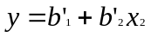
Now we want to introduce the variable x₃ into the model and check its significance towards the sum of squared regression (explained variation). Thus the new model is
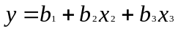
Now calculate the mean squared residual of this model.
Thus,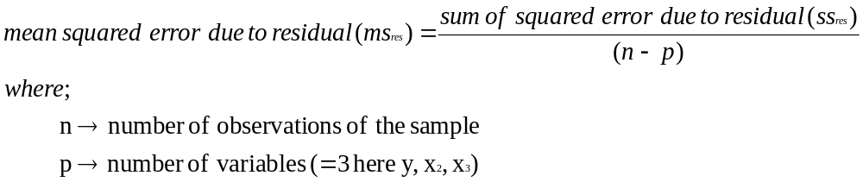

Now formulate a model with only x₃ as independent and y as dependent.(since, we are checking the significance of x₃ i.e., its contribution towards explained variation]. Say the model is

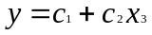
For this model calculate mean squared error due to regression
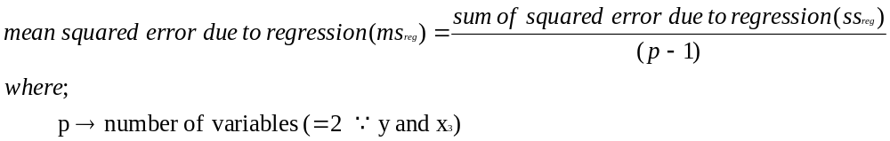
Thus the partial F for x₃ in the model
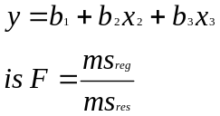
This is checked against the table value of F with (p-1) and (n-p); here, (2-1) and (n-3); degrees of freedom at a significance level, α. If the calculated F value is greater than F table value, retain the variable else reject or drop the variable from the model. The significance level (α) can be different while a variable is entered into the model (as in forward regression) from that when it is dropped from the model (as in stepwise regression). The α when a variable entered is called α of entry and when a variable is dropped, it is called α of exit. Generally, α_{entry} < α_{exit}. Even some statistical packages take this rule strictly. But it depends on the researcher to fix α_{entry} and α_{exit}. Generally, α_{entry} < α_{exit} so as to provide a shield to those already in the model. It will be seen in further sections of how they are important. Also it will be discussed why a variable which was already entered needs to be dropped or why its significance in the model got reduced when subsequent variable are added.

FORWARD REGRESSION: In this sort of regression one will start with a model with no variables. Then at each step one independent variable is added based on correlation. Then the model is checked for partial F of the added variable. If the added variable is significant it is retained or else dropped. The steps involved can be shown with the help of a flow chart as given below:
YES
NO
NO
YES
YES
NO
START
Form a correlation matrix of independent variables with dependent variable(y)
Select the variable with the highest correlation
Form the model
Check the significance with F Test
Is it significant
Model is y=y–
Form the model with that independent variable
Are there any other independent variables
Calculate partial correlations of remaining independent variables with Y, controlling fro the already present independent variables in the model
Select variable with highest partial correlation
Form the new model by entering this new variable into the model
Check for partial F of the new variable added
Drop that variable from the model
STOP
Is it significant
BACKWARD REGRESSION: This is same as that of forward regression but in reverse direction. Here there is no need to calculate correlations. Only partial F’s are suffice. The steps involved are:

NO
YES
START
Formulate the model with all the variables
Calculate Partial F’s of each independent variable in the model
Is F Calculated > F table Value
Drop the variable from the model
Formulate new model with remaining variables
STOP
Take the lowest Partial F and compare it with the Table value at a certain α

The partial F’s are calculated as though the variable is the last variable to be added to the model as in the case of forward regression. Which allows us to calculate the contribution of that variable to the total sum of squared due to regression (explained variation). This will be clear from the below diagrams. Consider the equation
Y=b₁+b₂x₂+b₃x₃ eq. 1
Our objective is to calculate partial F for x₃. Find out the mean squared residual for equation 1.
ms_{res_1}
ms_{reg_1}
Total Variation
Now formulate a model with only the independent variable whose partial F is being calculated i.e., x₃ so, the model will be
y=b’₁+b’₂x₃ ---eq.2
Calculate the mean squared regression for equation 2.
ms_{res_2}
ms_{reg_2}
Total Variation
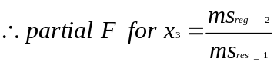
Note that here as and when each variable is removed the R² value gets lowered. The df to be taken while reading F Table value will be (2-1) df for numerator and (n-p) df for denominator. Where “p” is the total number of variables initially were.

The significance level considered will be more than that what we have used for α_{entry} in forward regression.

STEPWISE REGRESSION: This regression allows the researcher to add and delete variables simultaneously. Here there is no guarantee that a variable added will be retained in the model. It might be dropped out of the model consequently. This will happen because the significance of a particular independent variable in the model might get reduced when another variables are added, which leads to dropping of the variables. Here we use two significance levels. One is to accept a variable into the model (α_{entry}) and other to drop a variable from the model (α_{exit}). Here α_{entry<} α_{exit} so as to provide some sort of protection or give leverage to those variables already in the model. The steps involved are:

YES
NO
YES
NO
NO
YES
YES
NO
START
Form a correlation matrix of independent variables with dependent variable(y)
Select the variable with the highest correlation
Form the model
Check the significance with F Test
Is it significant
Model is y=y–

Form the model
Are there any other independent variables
Calculate partial correlations of remaining independent variables w.r.t. Y, controlling for the independent varables already in the model
Select variable with highest partial correlation
Form the new model by entering this new variable into the model
Check for partial F of the new variable added at α_{entry}
Drop that variable from the model
STOP
Is it significant
Calculate the Partial F of previous variables at α_{exit}
Are they significant
Drop those variables whose Partial F’s are insignificant

The correlation coefficient matrix is found out to be
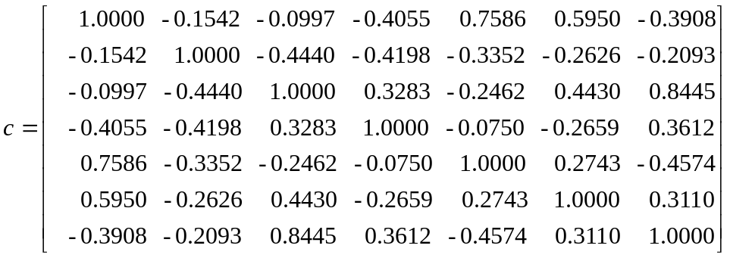

Therefore, the highest correlation with y₁ is 0.7586 of variable x₅. Therefore, now regress y₁ on x₅(R&D Intensity). The model is
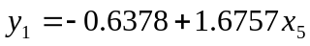

 | y1 | y1 pred | y1-y1pred | y1 pred -y1mean | ss res | ss reg
 | 1.27 | 1.842236 | -0.57224 | -1.022139 | 0.32745404 | 1.044768
 | 1.39 | 2.21089 | -0.82089 | -0.653485 | 0.673860392 | 0.427043
 | 3.2 | 2.395217 | 0.804783 | -0.469158 | 0.647675677 | 0.220109
 | 3.12 | 2.328189 | 0.791811 | -0.536186 | 0.62696466 | 0.287495
 | 3.19 | 2.646572 | 0.543428 | -0.217803 | 0.295313991 | 0.047438
 | 3.28 | 3.752534 | -0.47253 | 0.888159 | 0.223288381 | 0.788826
 | 4.41 | 5.042823 | -0.63282 | 2.178448 | 0.400464949 | 4.745636
 | 5.06 | 4.339029 | 0.720971 | 1.474654 | 0.519799183 | 2.174604
 | 4.17 | 2.914684 | 1.255316 | 0.050309 | 1.57581826 | 0.002531
 | 3.27 | 2.512516 | 0.757484 | -0.351859 | 0.57378201 | 0.123805
 | 3.41 | 3.71902 | -0.30902 | 0.854645 | 0.09549336 | 0.730418
 | 2.52 | 2.981712 | -0.46171 | 0.117337 | 0.213177971 | 0.013768
 | 1.08 | 2.04332 | -0.96332 | -0.821055 | 0.927985422 | 0.674131
 | 1.16 | 2.445488 | -1.28549 | -0.418887 | 1.652479398 | 0.175466
 | 2.24 | 2.04332 | 0.19668 | -0.821055 | 0.038683022 | 0.674131
 | 3.06 | 2.613058 | 0.446942 | -0.251317 | 0.199757151 | 0.06316
Total | 2.864375 |  |  |  | 8.991997869 | 12.19333
 | R² = | 0.575555
 | Adj. R² = | 0.545238
 | F = | 18.98428

The partial correlations of the excluded variables with y₁ controlling for the included variable X₅(R&D Intensity) is given below.
Excluded Variables |  | Partial Correlation
X₂ | Dominant specialization | .163
X₃ | Vertical integration | .138
X₄ | Import dependence | -.536
X₆ | Export competitiveness | .618
X₇ | Capital intensity | -.076

The highest of the partial correlations is 0.618 (Export competitiveness - X₆). Now this variable is included into the model. The model with X₅ and X₆ is

The corresponding R² and F values are
R² = 0.737422, Adjusted R² = 0.697026 and F = 18.25457.

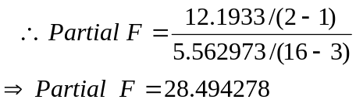

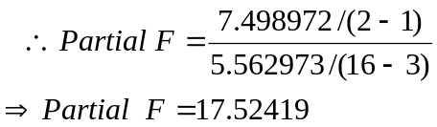
So, both the variables X5 and X6 are significant in the model.

The partial correlations of the excluded variables with y₁ controlling for the included variables X₅(R&D Intensity) and X₆(Export Competitiveness) are given below.

Excluded Variables |  | Partial Correlation
X₂ | Dominant specialization | .362
X₃ | Vertical integration | -.304
X₄ | Import dependence | -.498
X₇ | Capital intensity | -.578
The highest of the partial correlations is -0.578 (Capital Intensity – X₇). Now, this variable is included into the model.
The corresponding statistical inferences are
R² = 0.825084, Adjusted R² = 0.781355 and F = 18.86813

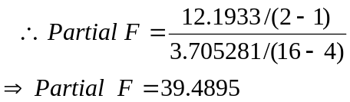

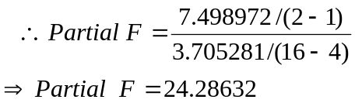

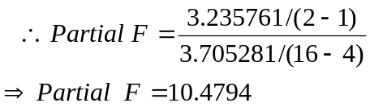

So, both the variables X5, X6 and X7 are significant in the model.

The partial correlations of the excluded variables with y₁ controlling for the included variables X₅(R&D Intensity), X₆(Export Competitiveness) and X₇(Capital Intensity) is given below.

Excluded Variables |  | Partial Correlation
X₂ | Dominant specialization | .176
X₃ | Vertical integration | .307
X₄ | Import dependence | -.231

The highest of these partial correlations is 0.307 (Vertical Integration – X3). Now we will include this variable into the model. The new model is
and, R²=0.841595, Adjusted R²=0.783992, F = 14.6105
But, when we calculate the Partial F for X₃, it is found out to be 0.690587 which is less than the F Table value at 1,11 df at 10% significance level. So, X₃ is excluded

